University of West London  School of Computing and Engineering | 
Human Centred Computing – Assignment 2
Title | Human-Centred Computing Strategy for the Design of a New System
Module | Human Centred Computing
Module Code | CP50073E
Module Leader: | Dr. José Abdelnour Nocera
Set by: | Dr. José Abdelnour Nocera
Moderated by: | Ann Austin
Assignment | Assignment 2
Hand in arrangements | This assignment must be submitted electronically through TurnItIn in Blackboard.
Structure of assignment | This assignment has one element. Each element has a specific weighting, and its own criteria. The learning outcomes of the module are assessed by a successful completion of all the elements. Feedback will be provided within 15 working days.
Structure of assignment | Element | Type | Weighting | Due Date
Structure of assignment | 1 | Individual Portfolio of Work (Max. 1500 words) | 50% | Week 13  8th of May 2016 11.59pm
Structure of assignment | Extensions will only be granted in exceptional circumstances. Extensions will be for 10 days or less. Documentary evidence will be required. Extensions must be agreed before the deadline.

Learning outcomes | LO 1 Understand and demonstrate the ability to apply principles from human-computer interaction to interactive systems design.  LO 2 Evaluate interactive systems quantitatively and qualitatively for their ease of use by target customer groups.  LO 3 Understand and demonstrate the ability to manage stakeholder-developer interaction during the requirements elicitation stage.  LO 4 Understand and demonstrate the ability to apply the principles of user interface design and information architecture to trans-mediated and multi modal interactive systems.  LO 5 Understand the dynamics of a multidisciplinary development team delivering a software system that meets the requirements of a target customer group.

Element 1
Title | Development of a human-centred strategy for the design and development of a new system
Task details | You will be responsible to write a portfolio of tasks comprising a human-centred strategy for the design and development of the Lyra Land Design Problem. Use the knowledge already obtained from completing the first assignment in order to help you prepare your strategy.  This strategy potfolio should include the following elements:  - Identification of key users and stakeholders (1 paragraph per stakeholder)  - Persona creation for each user profile: Lyra Leaders and Parents (1 paragraph per persona)  - Identify one key task for each of the following system elements: monitoring application for Lyra Leaders and for parents, activity booking systems and attendance tool. Produce a Work Domain Analysis for these tasks (one WDA per table – total of 4 tables)  - Interaction Design and Information Visualisation Recommendations developed from 2 out of the 4 WDA. Illustrate with sketch of user interfaces and control behaviours.  - How would you manage the integration of User-Centred Design and Agile Development activities in the for the Lyra Land system. (2 paragraphs + lifecycle PERT chart)  - If you were to design this system in Costa Rica, how would you address cultural differences in your approach to the process and product of interaction design of the Lyra Land system. Note cultural differences as per Hofstede’s study below. Note the contrast in terms of individualism and uncertainty avoidance. (2 paragraphs: one to discuss individualism and one to discuss uncertainty avoidance)  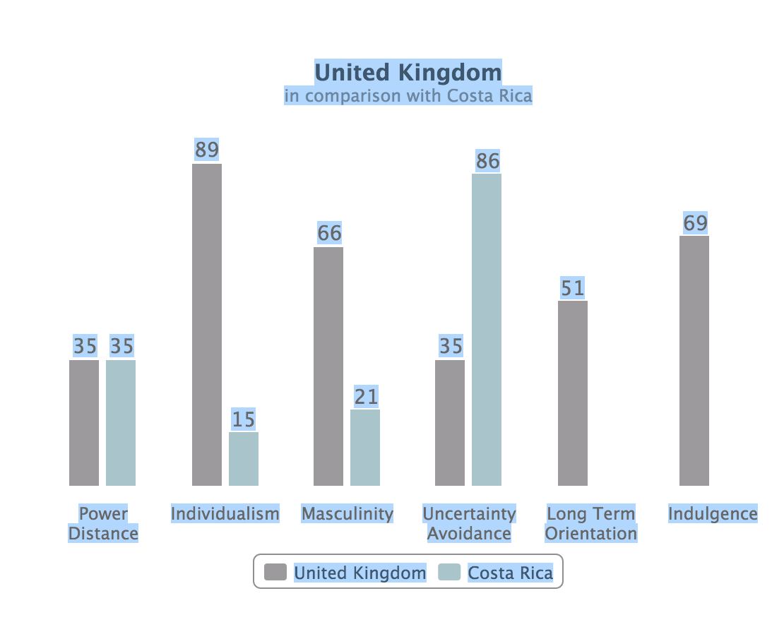
Marking Guide | Criteria | Issues | Mark | Marking breakdown where appropriate
Marking Guide | Application | Have you identified relevant stakeholders and users? | 10 | End users (5)  Other Stakeholders (5)
Marking Guide | Application | Have you composed two relevant personas following the examples presented in module materials? | 16 | Persona richness (8 x 2)
Marking Guide | Conceptual Understanding | Do you understand WDA levels and concepts in AH? | 10 | 2 marks for each level
Marking Guide | Application | Did you apply WDA correctly? | 24 | 6 marks for each table
Marking Guide | Design | Does the prototype reflect WDA findings? | 15
Marking Guide | Application | Have you considered how to integrate UCD and Agile lifecycles in the context of the case study? | 15 | Lifecycle stages identified for both approaches in PERT chart (5)  Discussion of how to integrate both in the context of case study (10)
Marking Guide | Analysis | Do you discuss how the contrast in each of the identified cultural dimensions will affect the process and product of interaction design? | 10 | Discussion on individualism (5)  Discussion on uncertainty avoidance (5)
 |  | TOTAL | 100

Grade descriptors

In addition to the assessment criteria above the following table may assist you in understanding how we arrive at your final mark. Indeed your final mark should agree with the following grade descriptors, but note that the assessment criteria are the main means of assessment.
Mark | Descriptor
0-39% | Limited conceptual understanding with possible interpretation deficiencies. Inappropriate arguments leading to unreliable and invalid conclusions/recommendations
40-49% | Some confusion in purpose & aims of the human-centred strategy. Some overall structure and conceptual understanding. Some indication of concepts and tools but arguments sometimes irrelevant, illogical or with unsupported assertions.
50-59% | Demonstrates a limited but accurate level of understanding of strategy presented in a basic manner in terms of concepts and application. The answer contains relevant interpretation and critical understanding especially at the upper end of the marking range.
60-69% | Demonstrates accurate knowledge and understanding of the subject presented in a coherent manner. The answer contains good evidence of application and interpretation of concepts and tools. At the upper end there is evidence of thoughtful and critical understanding of the design problem and decisions on the strategy presented.
70-79% | Demonstrates accurate knowledge and understanding of the subject presented in a coherent manner. The answer contains good evidence of application and interpretation of concepts and tools. There is evidence of thoughtful and critical understanding of the design problem and design decisions. Design proposal is innovative with a clear human-centred perspective.
80% or above | The assignment demonstrates scholarship through a depth of insight and understanding of relevant material, which is logically structured, accurate and well referenced. Originality of thought and application is evident. Demonstrates accurate knowledge and understanding of the subject presented in a coherent manner. The answer contains good evidence of application and interpretation of concepts and tools. There is evidence of thoughtful and critical understanding of the design problem and design decisions. Strategy report is innovative with a clear human-centred perspective.

Appendix
ADAPTED FROM M364 Fundamentals of Interaction Design Module Materials, Open University

Lyra Land design problem
Lyra Land is a new activity holiday destination in a quiet rural location in the North of England. Based on famous video computer game character Lady Lyra, an action loving explorer and adventurer, the resort features a number of indoor and outdoor activities: everything from climbing to kayaking, and from paint balling to Lady Lyra’s relaxation spa.


Lyra Land was built by former Internet entrepreneur Howard Holmes, and is a tribute to his belief in a philosophy of ‘free range’ children, i.e. that children be allowed the freedom to do things on their own in a safe environment without close adult supervision. Howard Holmes’s vision is that everything you need for your holiday is at the park such as shops, restaurants and laundry as well as entertainment, and that the environment is full of exciting places to explore and have fun, while being free from hazards such as cars.
To support this philosophy, there are enough staff (called Lyra leaders) for children to be within easy reach of a staff member at all times, and each guest is given a special bracelet that can track the owner’s whereabouts (see Figure above). This allows visitors registered to the same chalet to find each other, so for example, parents can track their children, and children can use the bracelet’s tracking system to find their parents in an emergency. About half of the Lyra leaders are local young adults working over the summer.
To make it fun and to encourage children to go exploring, the bracelet allows them to collect ‘treasure points’ by touching it to specially marked RFID targets. Treasure point targets are spread throughout Lyra Land’s four zones: Aztec Jungle (including a swimming pool), Ancient Rome (including a track for chariot racing), Ancient Egypt (including a pyramid maze) and Venice (including bumper boats). Treasure points can be redeemed for fun prizes throughout the week, or saved up and redeemed for a free holiday place next season (if they have collected enough points). The bracelets are similar to touch cards used on buses and trains, such as London Transport’s Oyster cards, and in many hotels.
After a successful first year, Howard Holmes has contracted Westuni UbiTech, a UK-based technology firm to improve and develop further the technological aspects of Lyra Land. Apart from the bracelet there are three main elements:
- A monitoring application. There are two main versions of the monitoring application: one for parents and one for Lyra leaders. The former will be available in each chalet, and will be designed to locate the people registered to that chalet. The latter is for Lyra leaders to allow parents or children to consult, and will be able to locate any of the people visiting Lyra Land at that time.
- An activity booking system. There are 36 different indoor and outdoor activities. Each has a start time and an end time. It has a number of free spaces. Information about the suitable age range or height range and expected skills, such as swimming, and any disabilities that can be accommodated, such as partially-sighted. The booking system is for use within the park and can be used by any visitors and any Lyra leaders. This is expected to be primarily web based.
- An attendance tool for Lyra leaders. This allows someone who is running an activity (such as pottery or paint balling) to identify everybody on the schedule and whether they have arrived. Attendees who have arrived for a class can be identified by name or with the bracelet.

